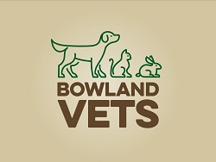

**Part time Consulting only Vet**

We are a newly established independent small animal practice in the heart of the Ribble Valley. Our team is made up of four Veterinary Surgeons, five RVNs, two SVNS, VCA and four receptionists.

We opened in June 2023; we offer GP services and some referral surgery and ophthalmology. We have many years combined experience of GP work and emergency hospitals.

We are looking for a motivated and enthusiastic team member. Communication skills are essential, and we are passionate about providing outstanding pet health care and customer service. We are looking ideally for a team member who is happy in a consulting only role.

We have an imaging suite with DR x-ray/ dental x-ray/ ultrasound, dental suite and two operating theatres.

Competitive salary, CPD allowance, RCVS fees paid, 1 in 4 Saturdays, no OOH and a days birthday leave.

If you would like a job description or to submit a CV and covering letter contact management@bowlandvets.co.uk